**Vanessa Langa**

**ST10247842**

**Documentation**

**Purpose**

It’s so easy to get sucked in to the world of productivity. Many university students have so many commitments and responsibilities. A lot of the time they barely have time to take care of their well being and neglect the fact that they are still human beings at the end of the day so their bodies need to be taken care of. The purpose of the Hydration Haven app is to motivate students to stay hydrated. It helps staying hydrated in a fun way. The target market for this app is university students. According to SpiceWorks (2022), the purpose of an app is to allow users to perform specific tasks on a mobile device. The Hydrate Haven App’s purpose is to notify students to log the amount of water they drank in a day. The app also calculates the average water intake in a week.

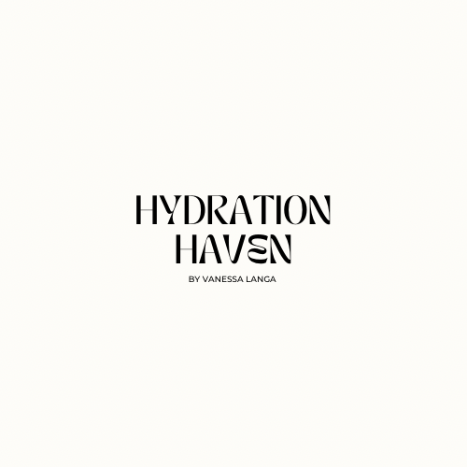

**Design Considerations**

**The Logo**

The logo for the Hydration App is very plain but it stands out quite nicely. The logo gives a very modern and aesthetic feel to it. I used the Application Canva to create the logo. The Font name is Tan Meringue in the size 23. The colour of the background is unique in the colour cream white. I have chosen this colour for the theme as it creates a unique and modern feel. Creating a unique and modern feel is appropriate because the target market is university students. University students are usually up to date with the trends. The nude and very subtle colours are trendy these days so the logo will attract the target market. According to logo.com (2024), the target market is becoming increasingly crowded, with millions of Apps so you need a logo that stands out to attract the right target market.

**The Splash Screen**

The splash screen consists of a unique design that grabs the user’s attention but also matching the colour scheme of the logo. For the background of the screen, I used the background colours available on Android Studio. The colour I used was brown. The Screen also includes the logo for the app. This Logo is positioned in the centre of the page to grab the user’s attention. The splash screen also includes my name and student name and a start button. The start button is in the bottom centre of the page so the user can start and use the app. The button is the easiest function to help the user navigate to the main page. There is also the exit button for the user to close the app. Inserted below is sample of the code and the splash screen.

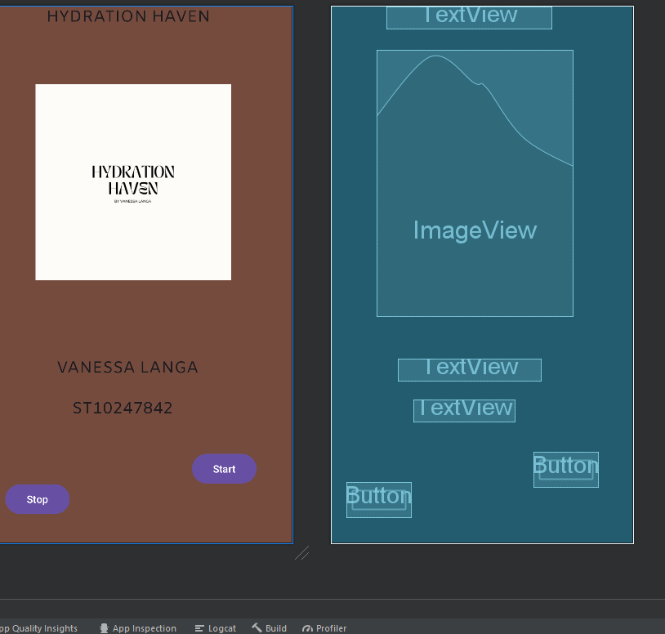

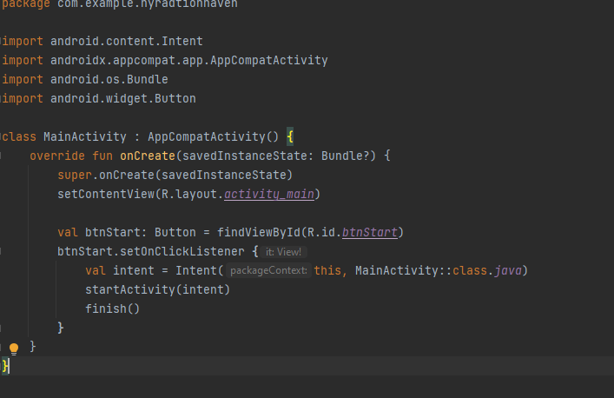

**The Main Screen**

The main screen is where everything takes place. This is the screen that gives the users the option to input the morning and afternoon water intake. It also allows the users to input any hydration notes that need to be taken into consideration. The user can input the following variables in a textbox. This screen also calculates the average water intake for the week. This average is displayed in a text box, but there is a button designed to calculate the average. The user can simply do this by pressing on the average button. There are 4 buttons that are used in this screen. The submit button, the average button, the detailed button and the exit submit. The submit button sends and saves all the inputs to the detailed view screen. The average button displays the average that was calculated, the detailed button shows all the inputs when clicked. The exit button exits the app and does not proceed to show the detailed screen. Below is a picture of the main screen. The main screen is the main screen so it has the longest code and and the screen with the most detail. The main screen has functions like the button that make it easier for the users to navigate from one screen to the other. The font is 16dp, this is because the screen of a mobile device is not big enough to bigger words. Theis size fits all of the relevant words needed for this application.

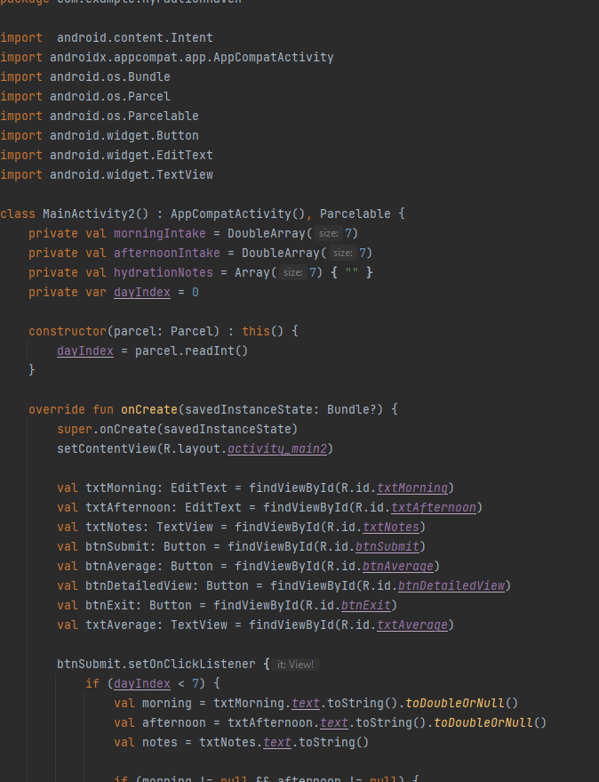

**The Detailed View screen**

This screen is made to display the details that were input in the main screen. I used the same colour scheme as the other colours. The detail screen will display all the information from the main screen. this information includes, the average, the daily water intakes and the hydration notes.

**Intuitive Design**

The applications is easy to follow. The controls are in simple image and big enough so the user can utilise them. The logo is big and bright and it makes it easy for the students to use. All the commands are simple and easy to understand.

**GitHub Actions**

As we needed to push our code to GitHub follow the steps of:

1. Make a repository, which is initialized with a README file.
2. Then pushing my Android Application from Android studio to GitHub, through the file management. Opening the application file
   1. At the top where path is show, click file, type CMD
   2. git init
   3. git add .
   4. git commit -m “final commit”
   5. git branch -M main
   6. git remote add origin **repository URL**
   7. git push -u origin main

**Conclusion**

Unfortunately, I did not have enough time to run the app but as displayed in the images provided, the was no errors in the code. The three screens are also visible as the requirements. The purpose of this app is help students manage their health properly. The purpose of this app has been fulfilled.

**Reference list**

**Books**

The Independent Institute of Education, 2024. Introduction to Mobile Application Development Module Manuel. Pretoria. South Africa.